NeuroFeed™ User Manual
  - Accessible Edition

NeuroFeed™
Assistive Robotic Feeding System

“Empowering Independent Eating”

Accessibility statement
This manual uses clear headings, simple language, and step-by-step instructions. It is written for elderly users and for people with visual or upper-motor disabilities. If you need this manual in large print, audio, or another format, contact Support.
Version: 1.0 | Date: 18 April 2026
Table of Contents

Quick Start (Accessible) 2
1. Introduction 3
2. Product Overview 4
Main components 4
3. Getting Started 4
4. Operating Instructions 4
5. Safety Guidelines 5
6. Troubleshooting 6
7. Care & Maintenance 6
8. Support & Contact 6
9. References 6

Quick Start (Accessible)
- Set up: Place NeuroFeed™ on a stable table in front of you.
- Food: Put soft, easy-to-scoop food in the bowl area.
- Power: Plug in the device. Confirm the green status light is on.
- Position: Sit upright and face the device.
- Start: Begin feeding. Keep hands away from moving parts.
- Finish: Turn off and unplug. Clean the spoon/gripper.
Accessibility tips: If you have low vision, increase screen zoom in Word (View > Zoom) and use Read Aloud (Review > Read Aloud). If you have limited hand control, keep the power plug easy to reach and ask a caregiver to assist with setup and cleaning.

1. Introduction
NeuroFeed™ is an assistive robotic feeding system designed to support individuals who experience difficulty eating independently. The device provides a safe, controlled, and user-friendly feeding experience.
It reduces physical strain while promoting independence and dignity during meals.

2. Product Overview

Main components
- Robotic Arm
- Gripper / Spoon Attachment
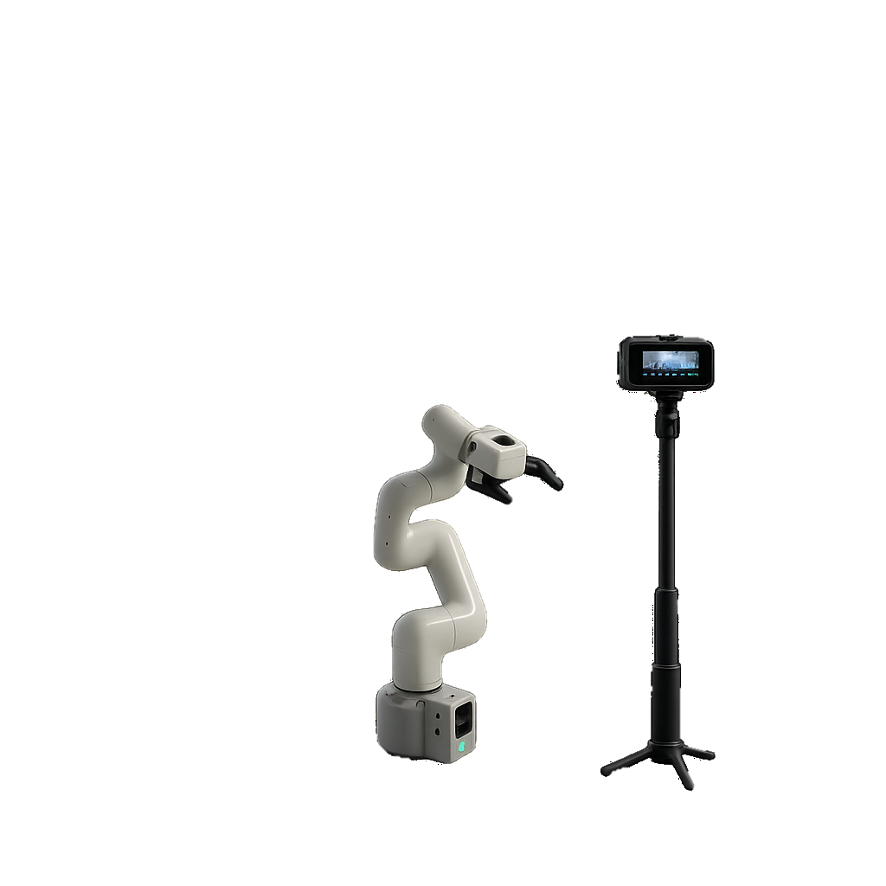
- Camera
- Status LED Indicator
c. Camera

- Robotic Arm

b. Gripper

d. LED Indicator
Figure 1: The NeuroFeed system consists of a robotic arm (a) used to move food, a gripper or spoon attachment (b) for holding food, a camera (c) positioned on a stand for tracking, and a status LED indicator (d) located on the base of the device.

3. Getting Started
Before using NeuroFeed™, ensure the following:
- Place the device on a flat, stable surface.
- Place the camera facing both the robot arm and your face
- Ensure the power cable is accessible.
- Prepare food that can be easily picked up by the device.

4. Operating Instructions
Step 1 — Position the device
Place NeuroFeed™ on a table directly in front of you. Ensure it is within comfortable reach.

Step 2 — Position the Camera
Place the provided camera on a table, angle it to show your face and the robot arm.

Step 3 — Prepare the meal
Place food in the bowl next to the robotic arm.
Avoid overly liquid or extremely hard food.

Step 4 — Power on
Connect the device to a power source.
The green LED light indicates the system is ready.

Step 5 — Begin feeding
Sit comfortably facing the device.
The robotic arm will:
- Move toward the bowl.
- Pick up food.
- Gently guide it toward your mouth.

5. Safety Guidelines
Follow these guidelines to reduce risk of injury or device damage:
- Keep hands away from moving parts during operation.
- Do not use with hot liquids or extremely hot food.
- Always operate on a stable surface.
- Turn off and unplug after use.
- Supervision is recommended during initial use.

6. Troubleshooting
Issue | Recommended action
Device does not turn on | Check the power connection and outlet, then try again.
Arm not moving | Restart the device. If the issue continues, power off and inspect for obstructions.
Food not picked properly | Use more solid food that can be scooped easily.
Movement seems incorrect | Reposition the device on a stable surface and ensure the bowl is placed correctly.

7. Care & Maintenance
- Clean the gripper after each use
- Wipe surfaces with a dry or slightly damp cloth
- Do not immerse the device in water
- Store in a clean, dry environment

8. Support & Contact
For assistance or inquiries:
- Email: support@neurofeed.com
- Phone: +974 XXX XXXX

9. References
- W3C Web Accessibility Initiative (WAI): Web Content Accessibility Guidelines (WCAG) 2.2.
- W3C WAI: Accessible Rich Internet Applications (WAI-ARIA) Authoring Practices Guide (APG).
- Microsoft support documentation: Create accessible Word documents (Accessibility Checker, headings, lists, and table headers).
- Internal product documentation (if available): NeuroFeed™ device specifications, cleaning instructions, and safety compliance documentation.

Note about WAI-ARIA: WAI-ARIA attributes are designed for web content and applications. Microsoft Word documents do not use ARIA roles/attributes directly. Instead, this manual applies accessibility best practices that support screen readers and assistive technology in Word (clear headings, meaningful lists, table headers, and instructions that do not rely on color alone).

